**Q: 1** Write a summary of the results of modeling these scenarios. Start by starting the current position; how much does Big Mountain currently charge? What does your modelling suggest for a ticket price that could be supported in the marketplace by Big Mountain's facilities? How would you approach suggesting such a change to the business leadership? Discuss the additional operating cost of the new chair lift per ticket (on the basis of each visitor on average buying 5 day tickets) in the context of raising prices to cover this. For future improvements, state which, if any, of the modeled scenarios you'd recommend for further consideration. Suggest how the business might test, and progress, with any run closures.

**A: 1** current price:$81.00, target price:$82.99, increase runs, vertical drop, and snowmaking_ac can increase the price effectively. The additional cost of some new chairs can lift the ticket, but not much help. Focus on the top three features to increase the ticket prices.

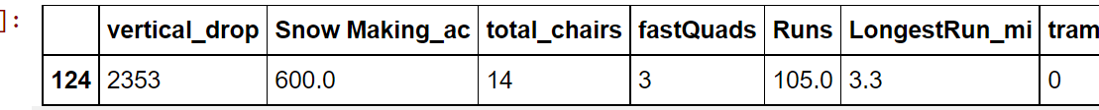

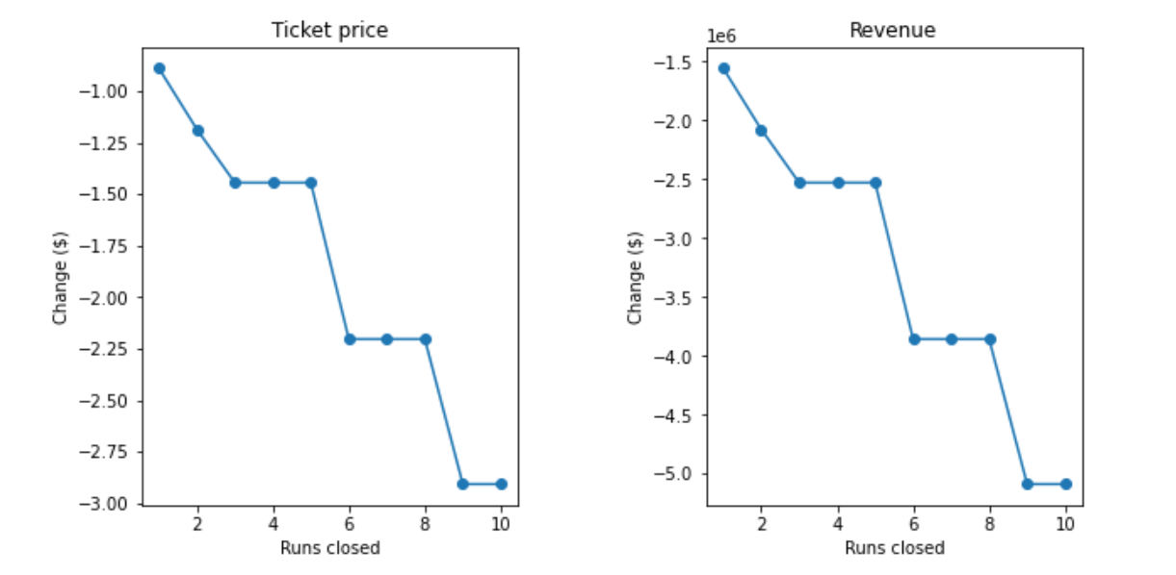

**Q: 2** What next? Highlight any deficiencies in the data that hampered or limited this work. The only price data in our dataset were ticket prices. You were provided with information about the additional operating cost of the new chair lift, but what other cost information would be useful? Big Mountain was already fairly high on some of the league charts of facilities offered, but why was its modeled price so much higher than its current price? Would this mismatch come as a surprise to the business executives? How would you find out? Assuming the business leaders felt this model was useful, how would the business make use of it? Would you expect them to come to you every time they wanted to test a new combination of parameters in a scenario? We hope you would have better things to do, so how might this model be made available for business analysts to use and explore?

There are some ways that can improve this model: the source of the data, the accuracy of the data, does the features have any collinearity etc.

Some other cost could be the equipment transportation fee, environmental fee for snowmaker etc.

There are lots of improvement space for the current price.I don’t think this is a surprise mismatch.

Try to follow the conclusion of the model and increase the numbers of Runs, vertical_drops and snow_making_ac. Then set a hypothesis test to test the result.

